Project Design Phase-II
Technology Stack (Architecture & Stack)

Date | 31 January 3035
Team ID | SWTID-2026-3086
Project Name | MediConnect – Smart Doctor Appointment Booking System
Maximum Marks | 4 Marks

Technical Architecture:
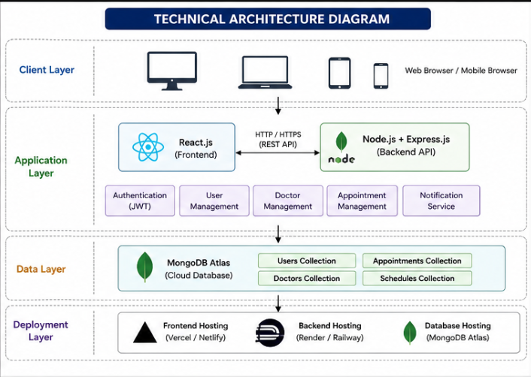

Table-1: Components & Technologies:
S.No | Component | Description | Technology
1 | User Interface | Patient, Doctor & Admin Web Portal | React.js, HTML5, CSS3, JavaScript
2 | Application Logic-1 | Authentication & Authorization | Node.js, Express.js, JWT
3 | Application Logic-2 | Appointment Management | Express.js
4 | Application Logic-3 | Doctor & Patient Management | Express.js
5 | Database | Store Users, Doctors, Appointments | MongoDB, Mongoose
6 | Cloud Database | MongoDB Atlas | MongoDB Atlas
7 | File Storage | Doctor Images & Profile Uploads | Multer, Local Storage
8 | External API-1 | Email Notifications | Nodemailer
9 | External API-2 | Authentication Tokens | JWT
10 | Machine Learning | Not Applicable | —
11 | Infrastructure | Deployment | Vercel (Frontend), Render/Railway (Backend)

Table-2: Application Characteristics:
S.No | Characteristics | Description | Technology
 | Open-Source Frameworks | List the open-source frameworks used | Technology of Opensource framework
 | Security Implementations | List all the security / access controls implemented, use of firewalls etc. | e.g. SHA-256, Encryptions, IAM Controls, OWASP etc.
 | Scalable Architecture | Justify the scalability of architecture (3 – tier, Micro-services) | Technology used
 | Availability | Justify the availability of application (e.g. use of load balancers, distributed servers etc.) | Technology used
 | Performance | Design consideration for the performance of the application (number of requests per sec, use of Cache, use of CDN’s) etc. | Technology used

